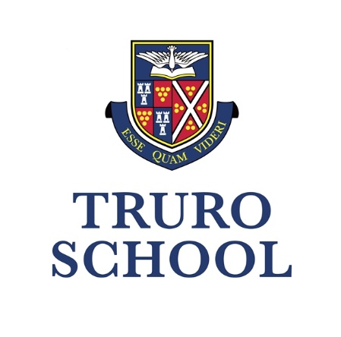

NURSERY | PREP | SENIOR | SIXTH

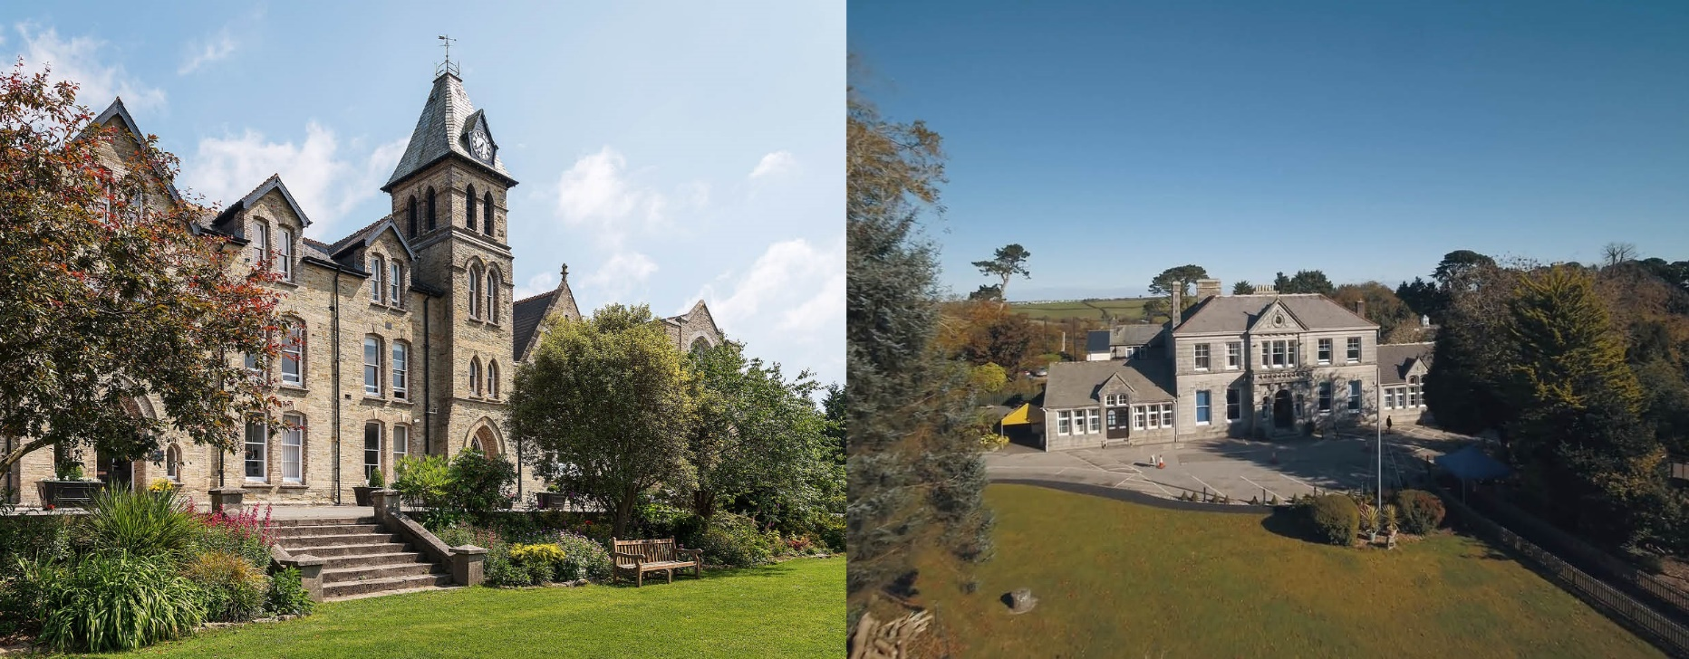

**Information for Candidates**

**Swim Teacher / Term Time Only**

**Truro School Prep**

Commence: August 2024

Zero Hour

From Kieran Topping

Chief Operating Officer

**Welcome to Truro School!**

Thank you for your interest in the role of Swim Teacher here at Truro School Prep.

Our School is steeped in 140 years of history, and is Cornwall’s leading coeducational independent school for children aged 3-18. We are situated over two campuses. The Senior School educates around 840 pupils and is set within 40 acres of sports fields and open spaces overlooking Truro and its iconic Cathedral. The Prep School educates around 300 pupils and is located next to the Royal Cornwall Hospital. We have superb facilities and resources at both sites that support our forward-looking educational ambitions.

Our Cornish setting allows us the privilege of working in a thriving city surrounded by beautiful rural and coastal opportunities. Our educational philosophy is to promote inclusive excellence, academically, pastorally and via a vibrant co-curriculum, for all who join our school.

Underpinned by a welcoming and liberal Methodist ethos, we champion the values of curiosity, courage, creativity, compassion and confidence in all we do. We want all our pupils to be and to become the very best of themselves, embracing the richness of a broad and forward-thinking education. We want our staff to be excited by what we are able to provide for the children under our care.

We are an “excellent[1]” co-educational school that is large enough to offer many diverse and exciting opportunities, but small enough to know our children and families well. We champion an ambitious, broad and balanced education, and we hope that everybody who joins us will feel an important part of this flourishing community.

For a flavour of life here at Truro School please look at our website [www.truroschool.com](http://www.truroschool.com) and view our virtual tour, where you will see and hear from staff and pupils, and find a glimpse of who we are and where we work.



Kieran Topping

Chief Operating Officer

**Job Description: Swim Teacher at Truro School Prep (Zero Hours)**

JOB TITLE:

Swimming instructor

REPORTING TO:

Sports Centre Manager

_____________________________________________________________________________

ROLE OVERVIEW:

We are looking for an experienced Swim teacher to work part time (term time only) for Truro School Enterprises to deliver parent and baby swim lessons (3 months to 4 years) as part of our Little Fishes swim programme run at Truro Prep School.

Flexibility is required to meet the needs of the business; typical lessons take place in the mornings for parent and baby classes, and we are looking for 2 mornings per week as well as support for sporadic lessons.

KEY FUNCTIONS:

* Ensuring all poolside activities and scheduled swim lessons are promoted effectively and delivered to the highest standard, creating an exceptional experience for our members.
* Responsible for planning creative and innovative classes.
* Preparing activity areas to include the safe setting up/dismantling of equipment and ensuring that all equipment is stored safely and securely when not in use.
* Providing a safe and enjoyable environment for all of our users within the pool & surrounding areas.
* Deliver great customer service by providing personal attention and care to all members.
* Ensure sessions run to time
* Accurately complete records for the function to track attendance.
* Working as part of a team to ensure the smooth operation of the facility.
* Follow Pool Safety Operating Procedures.
* Work closely with Swim management to meet and exceed set targets and objectives, help achieve commercial success within the department and wider Club team.

PERSON SPECIFICATION:

*Essential Criteria*

* STA level 2 certificate in teaching swimming **or** Swim England (ASA) level 2 certificate in teaching swimming. Together with;
* Exceptional communication skills and experience in a customer facing environment, able to respond appropriately & professionally to everyone you interact with in all manners, including face to face, over the phone & via email correspondence.

Desirable Criteria:

* STA Level 2 Award in Aquatic Teaching - Baby & Pre-School **or** Swim England (ASA) Level Teaching Pre-School Swimming

ADDITIONAL:

* Truro School is committed to safeguarding and promoting the welfare of children and young people and expects all staff and volunteers to share this commitment and behave accordingly. [Although there is no direct responsibility for children – *delete if not appropriate*], this role will involve daily contact with pupils.
* [Add other key information specific to the job eg, summary of working hours/pattern]
* This Job Description sets out current duties of the post that may vary from time to time without changing the general character of the post or the level of responsibility entailed.

*Truro School is committed to safeguarding and promoting the welfare of children and applicants must be willing to undergo child protection screening including checks with past employers and a Disclosure and Barring Service check.* *We embrace diversity and promote equality of opportunity. We welcome applications from all sections of the community.*

Our History

Truro School is the only HMC School in the beautiful duchy of Cornwall and a member of MIST (The Methodist Independent Schools’ Trust). It was originally a Direct Grant Boys’ Grammar School but became independent in 1976 and fully co-educational in 1990. Truro School Prep (Treliske School until September 2005) was opened in 1936 as the Junior Department to Truro School. It is a member of the IAPS (Independent Association of Prep Schools). Though, like the Senior School, Treliske was originally a boys’ school, it became co-educational in 1989. A Pre-Prep Department was opened in 1991. Truro School Prep is beautifully situated on its own separate campus, between the Royal Cornwall Hospital and Truro Golf Club.

Truro School Prep currently has 290 pupils between the ages of 3 and 11. Children in Year 6 work towards the Prep School Diploma and the school prides itself on having a broad and balanced curriculum. Each year about 95% of Year 6 (60 pupils) proceed into the 1st Year (Year 7) at the Senior School. Parents like to commit to the through-school ‘family’ and a large proportion of parents have more than one child across the School. The social life of the School is therefore an important feature of its ethos. At our Senior School there are currently 836 pupils, including a Sixth Form of around 190. In the Senior School there are also 75-80 boarders, national and international. There is no boarding at Truro School Prep. Day pupils travel from throughout the county to our School, including some on the school buses.

Our Motto

Esse Quam Videri, meaning ‘to be, rather than to seem to be.’

Founded by Methodists in Cornwall in 1880 our School is a welcoming community in which children and adults can flourish, thrive and be happy. They enjoy being and becoming the very best of themselves.

Our Values

From nursery through to Sixth Form, the values our community nurtures are:

* Curiosity to always want to discover and learn more, academically and more widely too.
* Confidence to build resilience by learning from both successes and failures alike.
* Compassion to understand and champion the needs of others, in our community and beyond.
* Creativity to be imaginative in how we express ourselves and approach new challenges.
* Courage to enjoy becoming the very best of who we are, with integrity and ambition.

Our Ambition

To be a community of inclusion and excellence delivering the best educational journey in the South-West.

Our community and its culture reflect our Methodist foundation and our ongoing evolution in an inspiring Cornish setting. In an ever-changing world, we support and challenge young people to thrive – personally, spiritually, academically, socially, and physically. We value our pupils in the diversity of their identities, beliefs, abilities, talents, interests, backgrounds, and needs. The happiness, energy and wellbeing of our community shapes and inspires who we are and who we can become.

Academic Life

Many of our pupils at Truro School celebrate exceptional results as they prepare to move on to the next stage of their lives, education and career. Our Upper Sixth pupils enjoy places at some of the best universities in the world including Oxford, Cambridge, and a range of Russell group universities.

49% of GCSE and iGCSE grades in 2023 awarded were 9-7 (or A*/A), with just under 17% at grade 9.

In the same year, we were pleased to report 43% of A-Levels were graded A*/A. Furthermore, 67% of all A-Level grades were graded at A*-B.

Further information can be found here: [www.truroschool.com/senior-school/academic/results](http://www.truroschool.com/senior-school/academic/results)

The Co-Curriculum

We believe that a rich co-curricular life is a key ingredient of an excellent education. Whilst having fun, participating in a wide range of activities, without academic pressures, pupils broaden their horizons and learn a new skill or extend existing skills. This develops confidence, self-esteem, teamwork and independent-thinking, communication skills and social development across all year groups. Our aim is for every Truro School student to leave us with a breadth of knowledge, understanding and a desire to continue with their selected passion. We encourage students to try a variety of activities, to embrace challenge, success and failure in order to grow.

Sport

Truro School has an enviable reputation for the high quality of its sporting provision. Several teams compete nationally and the School hosts elite sportsman in the fields of windsurfing, fencing and sailing to name but a few. All abilities are catered for and every student is encouraged to participate in order to maintain a healthy lifestyle.

Music

Truro School is one of the most busy and vibrant music departments in the country and is home to the Truro Cathedral choristers. Music is evident in all year groups with over 60 concerts each year involving our ensembles, choirs and bands. Tuition is available for numerous instruments including cello, violin, flute, clarinet, saxophone, drums. Over a third of our school undertake instrumental or vocal lessons each week from 30 of the county’s top specialist teachers.

Major events each term include the annual Hall for Cornwall Concert, the Junior and Senior Charity Concerts, jazz band and Nine Lessons and Carols.

Drama

Truro School is renowned for the quality of its drama productions which are held in our professional Burrell Theatre. The school runs a number of major productions throughout the year including the annual whole school play or musical, an annual sixth form drama project (including performing at the Edinburgh Fringe Festival every two years) and the junior play in the summer term.

Cornwall

Truro School is located in the county of Cornwall, in south west England. It is surrounded almost exclusively by water which makes it ideal for those who love to spend their downtime at the beach, surfing, sailing, windsurfing or just enjoying a coastal walk. With the nearest beach only a 15-20 minute drive either north or south from Truro School, it is most certainly a life style choice of many. Take a look at [www.visitcornwall.com](http://www.visitcornwall.com) for more information about how to get here, where to stay and what’s on.

**TERMS OF APPOINTMENT**

If you are appointed to the role, a formal offer will first be made verbally and then followed up with an offer letter and contract of employment. The following are for guidance and may or may not be available at the time of offer. Benefits are subject to change from time to time.

* Competitive salary based on the Truro School Salary Scales
* Pension scheme
* Lunch provided
* Free membership of the Sir Ben Ainslie Sports Centre and pool facilities
* Free weekly fitness classes for staff only
* Access to a wide range of books, magazines and DVDs through the School library
* Free parking
* Free fruit, tea and coffee
* Discounted school fees
* Employee Assistance Program
* Cycle to Work scheme
* Employee benefits platform
* Continued Professional Development and training possibilities.

Terms of Employment

This role is a zero hour position working part time, term time only, with no fixed hours. Shifts will be scheduled in advance, across 7 days of the week and includes weekend and evening work.

Salary

Core hours are paid at the hourly rate of £21.88.

Pension Scheme

Truro School complies with its legal obligations to provide access to a pension scheme. Non-teaching staff have a pension via L&G whereby the School double-matches an employee’s contribution, up to an employee contribution of 5%. So, where an individual contributes 5% to L&G, and the School will make a 10% contribution.

Employee Assistance Program/Employee Benefits Platform

Truro School utilises Care First as our EAP provider so all employees have access to a 24/7 helpline and website support. In addition, this platform gives to access hundreds of discounts, offers and savings from high street retailers to holidays, Marks & Spencer to Bloom & Wild.

Other Employment Checks

The offer of employment will be conditional upon satisfactory receipt of the following;

|  |  |
| --- | --- |
| 1. Proof of right to work in the UK 2. Enhanced criminal background check (DBS) & Barred List check 3. Two satisfactory references 4. Evidence of qualifications held | 1. Overseas criminal record check (if you have resided or worked out of the UK in the past 3 years) 2. TRA and section 128 check (if applicable) 3. Fit to Work Questionnaire 4. Acceptable self-disclosure form |

**APPLICATION PROCESS**

To apply for this position, you will need to complete and submit a formal application using our Truro School application form. We are unable to accept any CVs. This should be emailed to [recruitment@truroschool.com](mailto:recruitment@truroschool.com) or mailed to the School address.

Through the submission of your application form you should demonstrate your qualifications, skill, and experience in relation to the role you are applying for. This information will be assessed against the requirements detailed in the job description.

Once the closing date for applications has been reached we will shortlist applicants and you will be contacted in order to either be invited to interview or to be notified that you have not been successful this time. Our shortlisting process utilises anonymised application form in order to avoid any bias. If you are called for interview you will be asked to provide your right to work in the UK evidence, complete a self-disclosure form and a provide a copy of your qualifications. Additional selection methods such as a presentation or activities/tasks may be used and you will be notified in advance if that is the case.

References may be taken up prior to interview.

All applicants must be prepared to have a Disclosure and Barring Service (DBS) check and undergo any other appropriate child protection screening including checks with past employers.

The post for which you have applied is exempt from Section 4 (2) of the Rehabilitation of Offenders Act 1974 by virtue of the Rehabilitation of Offenders Act 1974 (Exemptions) Order 1975, amended 2013. If you are shortlisted and invited to interview, you must declare any relevant warnings, reprimands, cautions and/or convictions by completing a self- disclosure form prior to interview. Any positive disclosure will be discussed at interview.

Any information given will be treated in strict confidence and will be considered only in relation to your application for this post. Truro School does not discriminate against candidates with irrelevant criminal convictions. For further information on which offences should be disclosed please visit:

<https://unlock.org.uk/topic/about-criminal-records/>

and/or view the flowchart on our employment webpage.

Candidates who have a disability or any other special requirement should let the school know so that reasonable adjustments can be made during the recruitment process.

You should be aware that provision of false information is an offence and could result in the application being rejected or summary dismissal if the applicant has been selected and possible referral to the police and/or Department for Education.

**We look forward to receiving your application.**

1. As judged by ISI in 2017 at both our Senior and Prep Schools